ResearchDownload User Guide

Version: 1.0.7
DocCode: SW-BASE-UG-0051
Date: Apr 05, 2018



Important Notice
UNISOC Confidential and Proprietary

All data and information contained in or disclosed by this document is confidential and proprietary information of Spreadtrum&RDA and all rights therein are expressly reserved. By accepting this material, the recipient agrees that this material and the information contained therein is to be held in confidence and in trust and will not be used, copied, reproduced in whole or in part, nor its contents revealed in any manner to others without the express written permission of Spreadtrum&RDA. The contents are subject to change without prior notice. Although every reasonable effort is made to present current and accurate information, Spreadtrum&RDA makes no guarantees of any kind with respect to the matters addressed in this document. In no event shall Spreadtrum&RDA be responsible or liable, directly or indirectly, for any damage or loss caused or alleged to be caused by or in connection with the use of or reliance on any such content.
About This Document

Purpose
The ResearchDownload User Guide describes how to use ResearchDownload.

Intended Audience

Organization
This document consists of five chapters and is organized as follows.
Chapter | Describes
1 Introduction | File composition and running requirements of ResearchDownload.
2 Interface Description | The main interface, toolbar, and status area of ResearchDownload.
3 Quick Start | How to start the program, set the parameters, download the software, and quit the program.
4 Basic Operations | Basic operations such as parameter setting, packing, and configuration file setting.
5 CmdDloader | CmdDloader Operations

Contents
1 Introduction 1-3
1.1 System Overview 1-3
1.2 File Composition 1-3
1.3 Running Requirements 1-4
2 Interface Description 2-5
2.1 Main User Interface 2-5
2.2 Toolbar 2-5
2.3 Status Area 2-6
3 Quick Start 3-7
3.1 Running the Program 3-7
3.2 Setting Parameters 3-8
3.3 Starting Downloading 3-9
3.4 Completing Download Process 3-9
3.5 Stopping the Program 3-10
4 Basic Operations 4-10
4.1 Parameter Settings 4-10
4.1.1 Download Settings Dialog Box 4-10
4.1.2 Main Page Tab Page 4-12
4.1.3 Options Tab Page 4-13
4.1.4 Calibration Tab Page 4-14
4.1.5 Flash Operation Tab Page 4-16
4.1.6 Multi-Language Tab Page 4-17
4.1.7 LCD-Configure Tab Page 4-18
4.1.8 MCP Type Tab Page 4-18
4.1.9 Vol-Freq Tunning Tab Page 4-19
4.2 Packing 4-20
4.3 Modifying the Product Configuration File 4-21
4.3.1 Adding Products 4-21
4.3.2 Adding Backup Items 4-23
4.3.3 Adding the Special Configuraiton File 4-24
4.3.4 Hiding Some Products 4-24
5 CmdDloader 5-25
5.1 Overview 5-25
5.2 Running Requirements 5-25
5.3 User Guide 5-25
5.3.1 Param Format 5-25
5.3.2 Running the Program 5-26

Figures
Figure 2-1 Main user interface 2-5
Figure 2-2 Status area 2-6
Figure 2-3 Passed 2-6
Figure 2-4 Failed 2-7
Figure 2-5 Waiting 2-7
Figure 3-1 Download settings dialog box 3-8
Figure 3-2 Downloading progress 3-9
Figure 3-3 Downloading succeeded 3-9
Figure 3-4 Downloading failed 3-9
Figure 4-1 Download Settings dialog box 4-11
Figure 4-2 Serial port settings 4-12
Figure 4-3 Selecting the product 4-12
Figure 4-4 Selecting the file 4-12
Figure 4-5 FLASH settings 4-13
Figure 4-6 Options tab page 4-13
Figure 4-7 Calibration tab page 4-14
Figure 4-8 Flash Operation tab page 4-16
Figure 4-9 Multi-language tab page 4-17
Figure 4-10 LCD-Configure tab page 4-18
Figure 4-11 MCP Type tab page 4-18
Figure 4-12 Vol-Freq Tunning tab page 4-20
Figure 4-13 Packet Setting dialog box 4-21

Tables
Table 1-1 File composition 1-3
Table 2-1 Toolbar icons 2-5
Table 2-2 Columns in the status area 2-6
Table 4-1 Download settings dialog box elements 4-11
Table 4-2 Calibration tab page 4-14
Table 4-3 Flash Operation tab page 4-16
Table 4-4 Multi-language tab page 4-17

Introduction

System Overview
ResearchDownload is for developer to develop and debug and used to write the mobile software into the mobile device through the serial port or USB. It supports downloading to multiple mobile devices at the same time.
Connect the mobile device correctly to the serial port and switch it to boot mode, ResearchDownload will automatically start downloading.
After downloading into one mobile device is completed, manually replace the mobile device with another, and ResearchDownload will automatically detect the mobile device and start downloading again.

File Composition
ResearchDownload consists of the files described in Table 1-1.
                - File composition
Type | File
*.exe | ResearchDownload.exe
*.dll | BMAFrame9.dll
*.dll | BMPlatform9.dll
*.dll | Channel9.dll
*.dll | PortHound.dll
*.dll | ProcessFlow.dll
Configuration file | ResearchDownload.ini
Configuration file | BMFileType.ini
Configuration file | BMError.ini
Configuration file | BMTimeout.ini
Configuration file | BMAConfig.xml
Configuration file | Channel.ini
Configuration file | ProcessFlowSetting.ini
Configuration file | PhaseCheck.ini
Configuration file | MCPType.ini
Resource file | Rdl_bkmark.bmp

Running Requirements
ResearchDownload runs on Windows 2000/XP/Vista/Windows7. At least one usable serial port or USB is required.

Interface Description

Main User Interface
Figure 2-1 shows the main user interface.
              - Main user interface
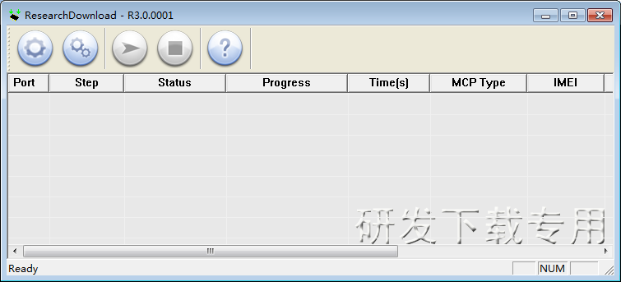

Toolbar
Table 2-1 describes the toolbar icons.
                - Toolbar icons
Icon | Description
 | Select the downloading packet file
 | Set the downloading parameters
 | Start downloading
 | Stop downloading
 | Version information

Status Area
Figure 2-1 shows the status area.
              - Status area
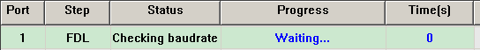
                - Columns in the status area
Column | Description
Port | Port number  If “X” is displayed, it means that ResearchDownload opens the port failed.
Step | Current file name or operation
Status | Current operation status
Progress | Download progress:  - Waiting indicates no mobile device is detected.  - Inprogress indicates downloading is ongoing.  - This column turns green when downloading is complete and red when an error occurs.
Time(s) | Cost time (second), each download

              - Passed
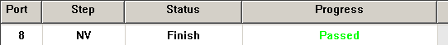

              - Failed
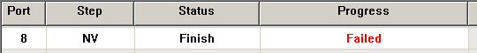

              - Waiting
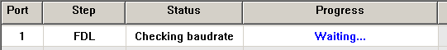

Note:
Waiting… indicates that an operation is being performed and it will take some time.

Quick Start

Running the Program
Run ResearchDownload.exe. The main interface is displayed, as shown in 2.1.1 Figure 2-1.

Setting Parameters
If you have a downloading packet file (*.pac), you can click to select downloading packet, and then click to set detail parameters. The Download settings dialog box is displayed, as shown in Figure 3-1.
If you have not the downloading packet file (*.pac), you can click to select the downloading files and set the parameters.
              - Download settings dialog box
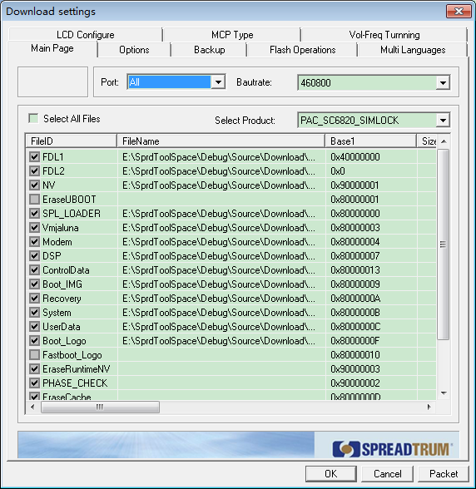

Note:
- The FDL(FDL1,FDL2) file shall be selected.
- Set the parameters when you run the program for the first time. Later you can set them depending on your own requirements.

Starting Downloading
Click . ResearchDownload automatically detects the available serial port and opens it. After the mobile device is correctly connected to the serial port, ResearchDownload starts downloading.
See Figure 3-1.
              - Downloading progress
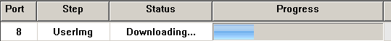

Note:
If the mobile device is connected to the serial port but download process is still not started, infer that:
- The mobile device is not powered.
- The serial port is being used by another program and therefore ResearchDownload cannot open it. To solve the problem, quit the program that is using the serial port.
- The mobile device is not in the boot mode state. Only when the mobile device is in the boot mode state, download can be started.

Completing Download Process
The downloading result is displayed in the status window, as shown in Figure 3-1 and Figure 3-2.
              - Downloading succeeded

              - Downloading failed

In manual mode, the downloading result is displayed until you click to start downloading again.

Stopping the Program
Disconnect the mobile device from the serial port.
In continuous downloading mode, if there are more mobile devices to be downloaded, connect it to the serial port and ResearchDownload automatically starts downloading again.
Click to stop downling.

Basic Operations

Parameter Settings

Download Settings Dialog Box
Click . The Download Settings dialog box is displayed, as shown in Figure 4-1.
              - Download Settings dialog box

Table 4-1 describes the elements in the Download settings dialog box.
                - Download settings dialog box elements
Element | Description
Port drop-down list box | Serial port setting
Baudrate drop-down list box | Baud rate setting
Select Product drop-down list box | Product to be downloaded
File list diagram | - FileName: Double-click this column to type the file path or click … to select the file.  - Base1: downloading address  - Size1: file size. Emtpy indicates that the file size is automatically calculated by ResearchDownload during downloading.
Select All File check box | Select all the files.
Packet button | Pack the downloaded files

Main Page Tab Page

Setting the Serial Port
The Port drop-down list box lists all the usable serial ports. You can select one serial port or All.
The baud rate can be 57600, 115200, 230400, 460800, or 921600. The default option is 115200. If you select the baud rate that not matches the mobile device, the serial port may not be opened or downloading cannot be performed.
See Figure 4-1.
              - Serial port settings
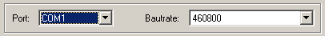

Selecting the Product
The configuration file presets the available products and you can select the matched product to determine the downloading addresses of files. See Figure 4-1.
              - Selecting the product

Selecting the File
Check the files to be downloaded in the FileID column.
Double-click the FileName column to type the file path in or click … to select the file. See Figure 4-1.
              - Selecting the file

Note:
The file name is ***.bin and is released with the program. Generally, the first file is FDL(1) and shall be downloaded. The FileName column cannot be null.

FLASH Settings
If you select the FLASH, ResearchDownload will erase the section of mobile device flash. The address and size of the flash section is shown in Figure 4-1.
              - FLASH settings

Options Tab Page
              - Options tab page
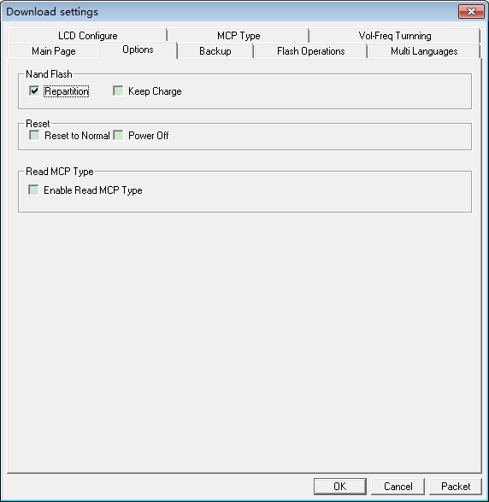

- Repartition
ResearchDownload will repartition the NAND flash during downloading FDL2, only if the NAND flash is initialized failed, no matter what errors occur the fail. In this case, it is not sure that all the data in the flash is erased, and it will depend on FDL2 itself.
- Keep Charge
Keep V-charge.
- Reset To Normal
ResearchDownload will send reset command to the phone at the end of download process if you check this item.
- Power Off
ResearchDownload will send power offcommand to the phone at the end of download process if you check this item
- Enable Read MCP Type
ResearchDownload will read MCP Type and display it.

Calibration Tab Page
              - Calibration tab page
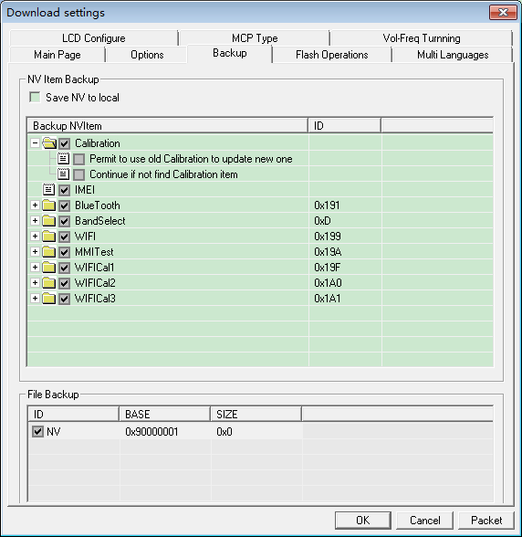
                - Calibration tab page
Element | Description
Calibration | Check Calibration and then the following sub check boxes become available:  - Permit to use old calibration to update new one: If the version is earlier than that in the mobile device, check this box and calibration backup will go on, but if you do not check it, an error message will be given. Pay attention that the versions will be consistent after calibration backup. The default option is clearing the box.  - Continue if not find calibration item: If any item is not found, check this box and calibration will go on, but if you do not check it, an error message will be given. The default option is clearing the box.
IMEI | Checked by default
Blue Tooth | Checked by default
Save To local | Checked by default
The functions of “Continue if not find calibration item” in Bluetooth is the same as that in Calibration.
Note:
If the NV parameter file is null, the settings here are ineffective during downloading.
Every time you run the program, these options will be reset to the default settings.

Flash Operation Tab Page
              - Flash Operation tab page
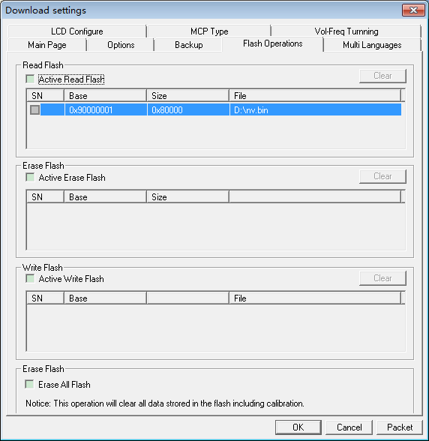
                - Flash Operation tab page
Element | Description
Active Read Flash | Active the read flash function
Active Erase Flash | Active the erase flash function
Active Write Flash | Active the write flash function
SN | Serial Number, it have check or un-check state
Base | The flash address
Size | Read size
File | Save to local file path
Clear | Clear the SN-Base-Size-File list
Erase All Flash | To erase all flash; some products maybe not support.

Multi-Language Tab Page
              - Multi-language tab page
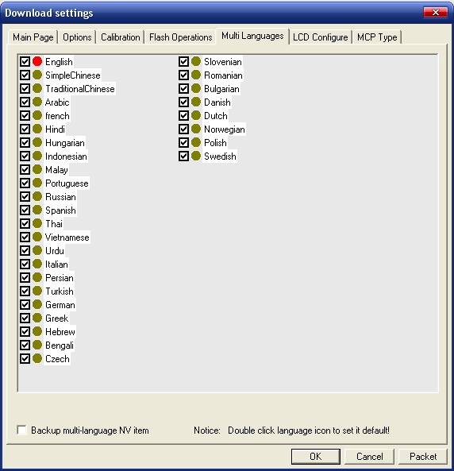
It is used to set the supported languages in NV file specially. You can double click the icon ball to set default language.
                - Multi-language tab page
Element | Description
 | Red-ball is default language
 | Normal supported language
Backup multi-language NV item | Select to backup the multi-language NV item or not

Note:
If the NV file is not set or included supported language information, this page will be empty.

LCD-Configure Tab Page
              - LCD-Configure tab page
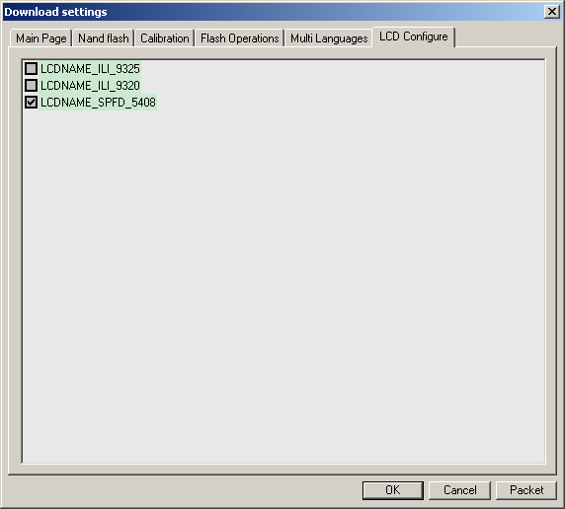
It is used to set the supported LCD in PS or UserImg file specially.
Note:
If the PS or UserImg file is not set or included LCD information, this page will be empty.

MCP Type Tab Page
This page is used to set if check the MCP type in downloading process. Check “Check MCP Type” to check the MCP type if matched the checked MCP type if the list. The MCP types are configured in the file MCPType.ini. You can add MCP types in this file.
              - MCP Type tab page

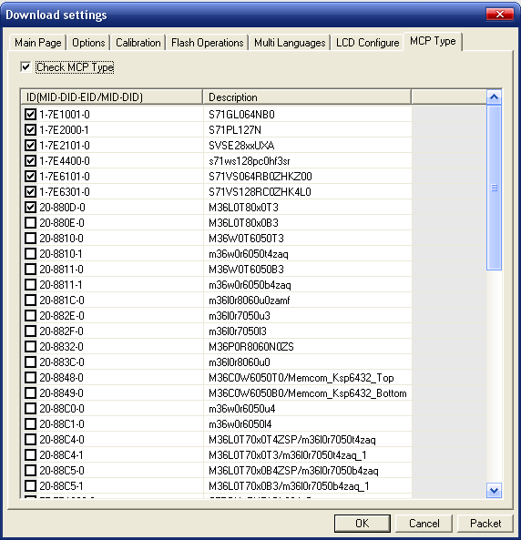

Vol-Freq Tunning Tab Page
This page is used to configure voltage and frequence for SPL Loader file. And the configure result will modify the SPL loader file. So if necessary, please backup this file before modify the parameters.
              - Vol-Freq Tunning tab page
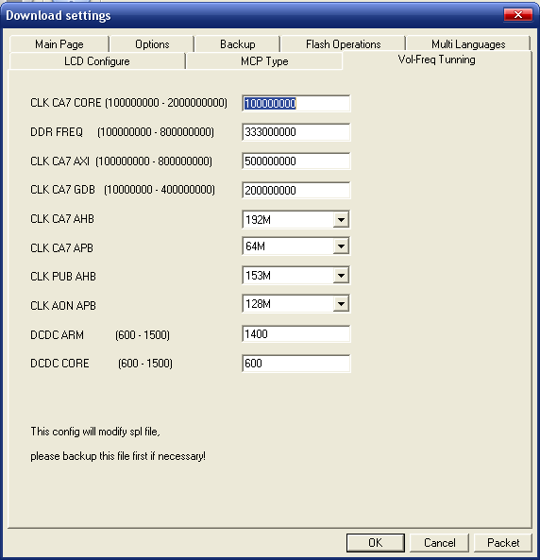

Packing
          - In the Download settings dialog box shown in 3.2.1 Figure 3-1, select the product to be packed.
          - Select the files to be packed.
- The PhaseCheck file is used only for downloading production tools. It shall be selected.
- If packing aims at SPUpgrade,
- The PhaseCheck file can be ignored. Even if it is selected, it is ignored during downloading.
- The Flash file shall be selected.
          - Set the parameters on the Nand Flash and Calibration tab pages.
- The sub boxes of Calibration shall be selected.
- The parameters on the Nand Flash tab page shall be correctly set. Otherwise, error messages will be given during unpacking.
- If you select repartitioning, back up the NV and select all the files. Otherwise, error messages will be given during unpacking.
          - Click Packet.
The Packet Setting dialog box is displayed, as shown in Figure 4-1.
              - Packet Setting dialog box
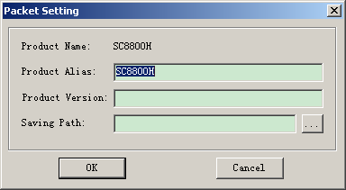

          - Type the production version and the saving path.
You can also click … to select the saving path.
          - Click OK.

Modifying the Product Configuration File

Adding Products

Adding a Scheme
If the file information of Product is the same as that of Scheme, skip this segment. Otherwise, do as follows:
Under <SchemeList>, add a node at the end:
<Scheme name = “XXX">
<File>
<ID>FDL</ID>
<Type>FDL</Type>
<Block>
<Base>0x30000000</Base>
<Size>0x0</Size>
</Block>
<Flag>0</Flag>
</File>
...
</Scheme>
Pay attention to the following points:
- XXX is the Scheme name. It cannot be the same as those Scheme names under <SchemeList>.
- The first file shall be a FDL file.
- For the file type, consult relevant engineers. If necessary, you can add file types in BMFileType.h, for example, <ID>FDL2</ID>. For NAND Flash, the file type should be <Type>NAND_FDL</Type>.
- Base and Size are both hexadecimal and start with 0x. The initial value of size is generally 0x0 except when the file ID is Flash.
- Flag is generally 1, which indicates importing the file. If the file ID is Flash, Flag is 0.

Adding a Product
Under <ProductList>, add a new node at the end.
<Product name="YYY" [enable="1"]>
<SchemeName>XXX</SchemeName>
<FlashTypeID>0</FlashTypeID>
<Mode>0</Mode>
<NvBaseAddrChangeFlag>0</NvBaseAddrChangeFlag>
<NvNewBasePosition>1</NvNewBasePosition>
<NVBackup backup="1">
<NVItem name="Calibration" backup="1">
<ID>0xFFFFFFFF</ID>
<BackupFlag use="1">
< NVFlag name ="Replace" check ="0"></ NVFlag >
< NVFlag name ="Continue" check ="0"></ NVFlag >
</BackupFlag>
</NVItem>
<NVItem name="IMEI" backup="1">
<ID>0xFFFFFFFF</ID>
<BackupFlag use="0"></BackupFlag>
</NVItem>
</NVBackup>
<ProductComment></ProductComment>
</Product>
Pay attention to the following points:
- Product name YYY cannot be the same as the names under <ProductList>.
- [enable="1"] is optional.
- SchemeName is the scheme name created in the previous segment or the existing names under SchemeList.
- If Product is NAND Flash, FlashTypeID is 1. If Product is NOR Flash, FlashTypeID is 0.
- For single mode products, Mode is 0. For dual mode products, Mode is 1.
- NV backup items is either Calibration or IMEI, the backup of which is 1 and the ID of which is 0xFFFFFFFF. Other items have their own IDs.
- NVFlag name is either Replace or Continue. The former indicates that the old NV items are replaced with the new items. The latter indicates that if no NV items are found, the operation will go on.

Adding Backup Items
<Product name="YYY" [enable="1"]>
<SchemeName>XXX</SchemeName>
<FlashTypeID>0</FlashTypeID>
<Mode>0</Mode>
<NvBaseAddrChangeFlag>0</NvBaseAddrChangeFlag>
<NvNewBasePosition>1</NvNewBasePosition>
<NVBackup backup="1">
<NVItem name="Calibration" backup="1">
<ID>0xFFFFFFFF</ID>
<BackupFlag use="1">
< NVFlag name ="Replace" check ="0"></ NVFlag >
< NVFlag name ="Continue" check ="0"></ NVFlag >
</BackupFlag>
</NVItem>
<NVItem name="IMEI" backup="1">
<ID>0xFFFFFFFF</ID>
<BackupFlag use="0"></BackupFlag>
</NVItem>
<NVItem name="BlueTooth" backup="1">
<ID>0x191</ID>
<BackupFlag use="1">
< NVFlag name ="Continue" check ="0"></ NVFlag >
</BackupFlag>
</NVItem>
</NVBackup>
<ProductComment></ProductComment>
</Product>
- The new backup item name cannot be Calibration or IMEI.
- Use BackupFlag as follows:
- <BackupFlag use="1">
< NVFlag name ="Replace" check ="0"></ NVFlag >
< NVFlag name ="Continue" check ="0"></ NVFlag >
</BackupFlag>
- <BackupFlag use="0"></BackupFlag>
- <BackupFlag use="1">
< NVFlag name ="Continue" check ="0"></ NVFlag >
</BackupFlag>
- The new backup item ID cannot be the same as that of the ID of Calibration or IMEI.

Adding the Special Configuraiton File
To add the special configuration file, refer to the Instruction_for_modifying_the_XML_configure_file.
Pay attention to the following points:
- If a product in the BMAConfig.xml has the same name as a file in the private configuration file, replace the former with the latter. If there are multiple private configuration files, the standard configuration of the same products is the latest one.
- The extended name of the private configuration file shall be xml.
- The directory of the private configuration file shall be on the same level as that of the BMAConfig.xml.

Hiding Some Products
You can hide some products in the BMAConfig.xml or other special configuration files in one special configuration file.
<ProductList>
...
<Product name="XXXX" enable="0" > //method 1
...
</Product>
<Product name="YYYY" enable="0"/> //method 2
</ProductList>
Pay attention to the following points:
- Method1: set enable to 0 or 1 to hide or display a product.
- Method2: set enable to 0 to hide a product. It cannot be set to 1 because it has no detailed product description.

CmdDloader

Overview
CmdDloader is a command-line application , the application needs to use download software tools . CmdDloader application will invoke the download tool and monitor the download progress and results.

Running Requirements
CmdDloader runs on Windows 2000/XP/Vista/Windows7.

User Guide

Param Format
Start the command line of the application, Param format as below:
> CmdDloader.exe <-pac PacFile> [-port ComPort] [-c]
e.g. CmdDloader.exe -pac D:\SC7702_sc7701.pac -port 195
Explanation：
• -pac PacFile : int put pac file.
• -port ComPort : input device’s download COM Port Number.
• -c : The command is non- mandatory. If select this param,Clear
the download process before CmdDloader execution download.
• The port information is not specified, the application will automatically find a suitable download download port. The WaitDUTTimeout configuration item in CmdDloader.ini allows you to set the time you want to look for a valid device. For 0, unlimited unlimited wait until a suitable download port is found.

Running the Program
- DownLoad Passed
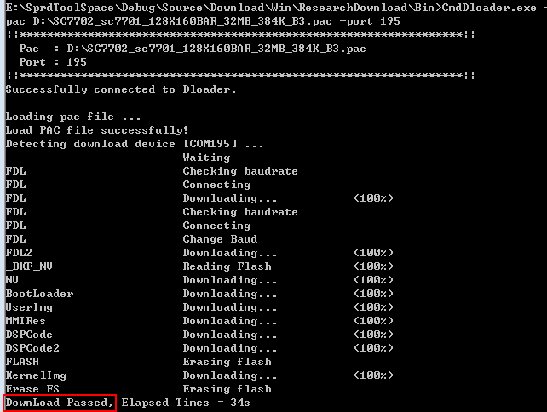
- Download failed
